Mango db ASSIGNMENT

Q1 Install MongoDB database server
sudo apt-get install gnupg curl
RUN BELOW COMMAND
curl -fsSL https://pgp.mongodb.com/server-7.0.asc | \sudo gpg -o /usr/share/keyrings/mongodb-
server-7.0.gpg \--dearmor

Q2 Create a directory/folder to store MongoDB datafiles
ans Create the /etc/apt/sources.list.d/mongodb-org-7.0.list file for Ubuntu 22.04 (Jammy):

Q3 Set necessary path environment variable
sudo apt-get update
Q 4 ans sudo apt-get install -y mongodb-org
Q 5 ans
sudo systemctl start mongod
sudo systemctl status mongod
Q 6 View list of available databases

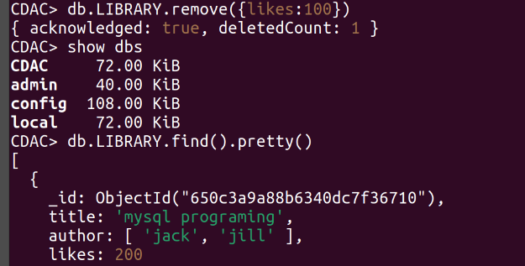
1

Q7 8 Q9 ans create database show create collection LIBRAY and show
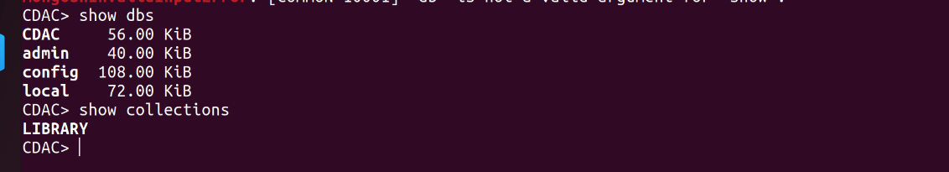
2

(Q10 and Q11) Insert the following document in the LIBRARY collection:-
title:'MongoDB programming', author:'Sameer', likes:100
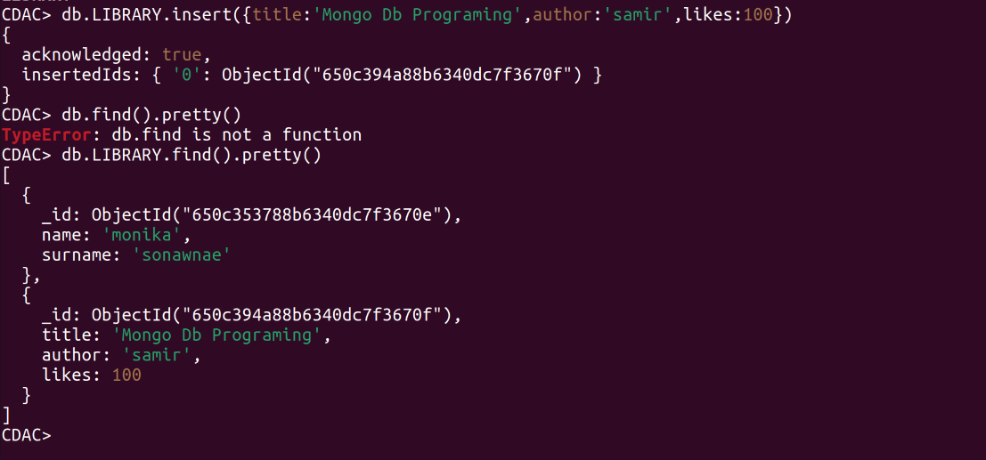
4

Q12Insert another document in the LIBRARY collection as follows:-
title:'MySQL programming', authors:['Jack','Jill'], likes:200
Q13 view document
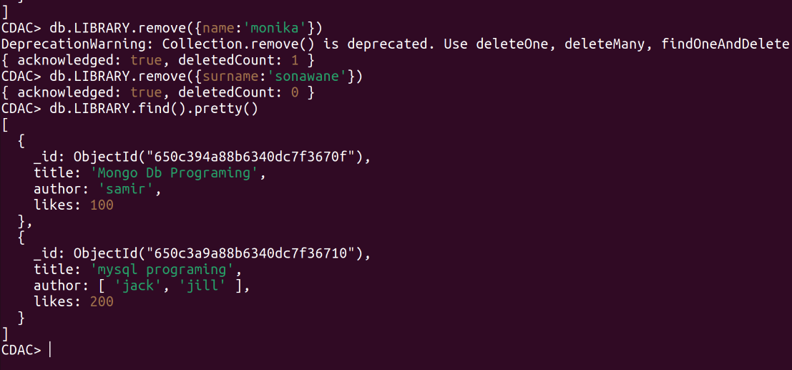
13

Q 14 and 15View only the first inserted document
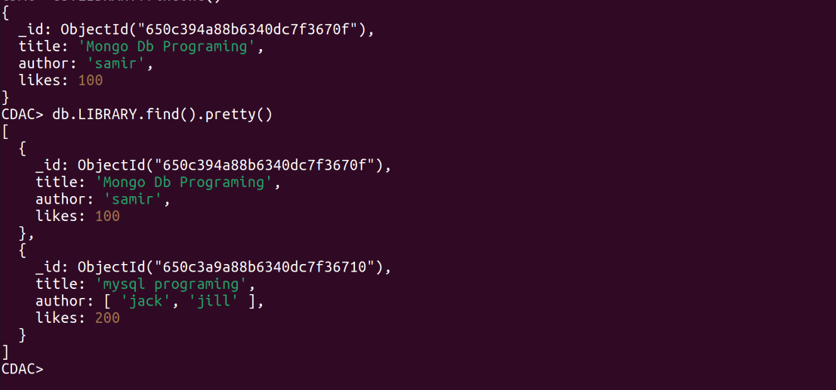
15

Q16Update the document where author name = Sameer and change it to Sameer Dehadrai
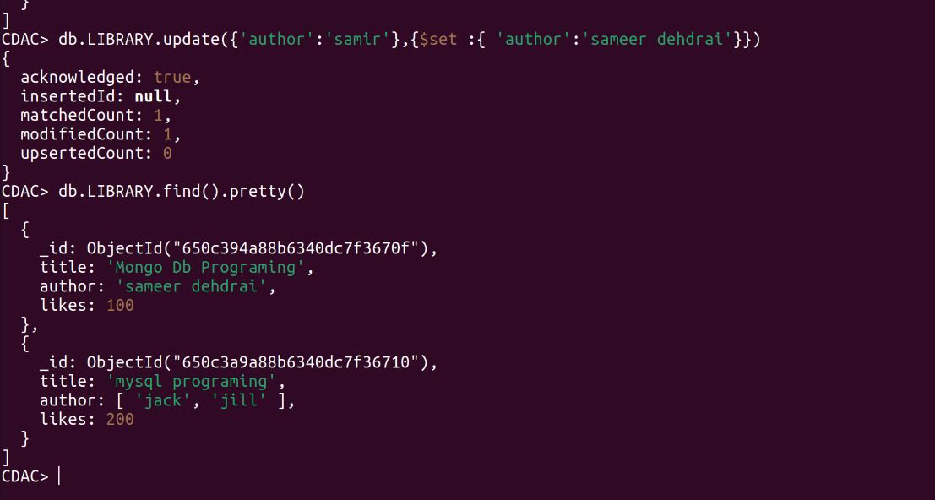

Q17Delete all documents that have 100 likes
18

Q18 Drop the LIBRARY collection
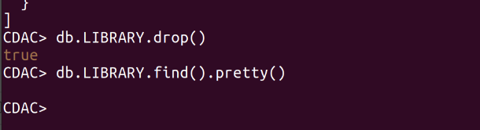
19
19 Drop the CDAC database
20
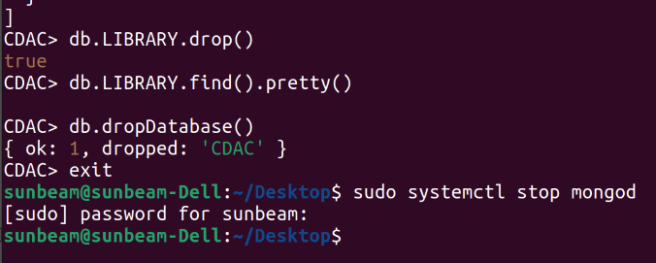
23

Q20 and 21 Exit from MongoDB shell Stop MongoDB server

